POLYETHYLENE TARP
Here’s a description of the polyethylene material used in the manufacture of polytarps from KAPS TEX CO., LTD, a woman-owned, green manufacturing company in China that is one of the largest polytarp producers in the world. Polyethylene is also used to make the “Bagster,” a Waste Management Co. product sold at Home Depot that holds up to 3300 lbs. of construction debris. In its heavier forms, polyethylene is plenty tough and durable for use as sails requiring a force of over 96 lb./sq. in. to over 100 lb./sq. in. to stretch to failure according to five separate tensile strength tests at a Goretex manufacturing facility. (For comparison purposes, 1lb./sq. ft. is the pressure on a sail at Force 6 on the Beaufort Scale [strong breeze of 25-31 mph]). Besides its lower cost and chemical makeup, polytarp differs from Dacron and other sail materials in being less stiff and more resilient. Its resiliency allows it to stretch under load in certain ways that are conducive to making sails from a single large sheet of material, instead of having to arrange strips of the same material in panels in order to shape it. Is polyethylene tarp sailcloth? Probably not, but what sail material is sail “cloth” today? Most sail materials today are made from some form of oil-based woven or laminated polymers such as polyester, nylon, or now, polyethylene.


Home >> Products Category >>Tarpaulin >> What is Tarpaulin?
* Structure
HDPE scrim and LDPE lamination on both sides. Reinforced PP rope in all four-side hem. Double stitched or welded. Aluminum, Polycarbonate, Brass grommets at certain intervals, Plastic reinforced corner bars. U.V. and F.R. treatment available.
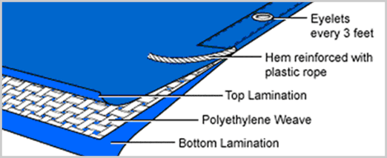
* Tarpaulin Usage
Trailer awning, Truck cover, machinery, grain & hay cover, ground sheet (printing available), boats cover, windbreak, construction and equipment cover, canopy, Pool cover etc.
*Poly tarp (Tarpaulin)
Poly Tarps are made with a plastic type material that is very strong and waterproof. There is a polyethylene coating that covers over the nylon tarp material. Poly is the abbreviated term for polyethylene. Poly or polyethylene tarps can come with a U.V. treated coat over the poly tarp material which helps protect it for sunlight. Polyethylene (PE) is the largest volume polymer consumed in the world. It is a versatile polymer that offers high performance relative to other polymers and alternative materials such as glass, metal or paper. Poly tarps are made with polyethylene, nylon tarp threading inside the material with rope reinforcement around the perimeter of the poly tarp material. Polyethylene (PE) resins are milky white, translucent substances derived from ethylene (CH29CH2). Polyethylene, with the chemical formula [8CH28CH28]n (where n denotes that the chemical formula inside the brackets repeats itself to form the plastic molecule) is made in low- and high-density forms. Low-density polyethylene (LDPE) has a density ranging from 0.91 to 0.93 g/cm3 (0.60 to 0.61 oz/cu in). The molecules of LDPE have a carbon backbone with side groups of four to six carbon atoms attached randomly along the main backbone. LDPE is the most widely used of all plastics, because it is inexpensive, flexible, extremely tough, and chemical-resistant. LDPE is molded into bottles, garment bags, frozen food packages, and plastic toys or in this case polyethylene tarps.



