BALANCED LUG JIFFY REEF
BACKGROUND...
Balanced lugsails are pretty interesting. I suppose they are one step away from a square sail. They no doubt have a long history that predates any fancy hardware, and now that fancy hardware is expensive and hard to find in some areas a fellow can still make an effective lugsail with stuff from the lumberyard. The spars are very short for the area set and need no standing rigging, making the lug ideal for a cartop or trailer boat that needs to be rigged in a few minutes. Here are the basics of the balanced lug sail:
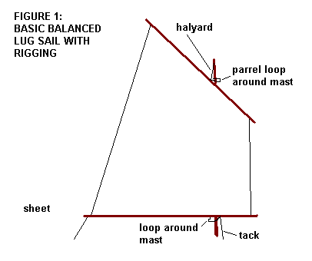
To review a bit, this sail is "balanced" a bit around the mast, the best place to fasten the halyard to the yard is about 40% aft of the luff. Further forward and the sail will twist a lot and lose the ability to point well into the wind. Properly set up these sails will tack through about 100 degrees, very good for such low tech. The yard needs to be fastened loosely to the mast at the halyard with a parrel loop of some sort to keep it located especially in rough water. There are lots of ways to do that and rigging a balanced lug was covered in detail in another issue of this site. Down at the boom is a tack line set about 15% aft of the luff, although this is not as critical as the halyard location. Again, the tack line needs a parrel loop of some sort to keep the boom from moving in rough water. The tack needs to be set VERY tight, thus putting great tension in the luff. Without that tension the sail will twist when sailed to windward with great loses. (In fact since the tack is so short and easy to get at I always make it at least a two to one tackle. A simple effective set up is a line running from the hull, over the boom, and back to the hull to a cam cleat. A quick yank at the cam cleat will retension the rig in an instant in a two to one effort.) Lastly there is the sheet, the location of which is usually not critical at all. When sailing the balanced lug, the sail is left standing from tack to tack. One tack will result with the sail draping over the mast but the effect is not noticable no matter how bad it looks. The sail is usually very gentle in a jibe.
There are two other types of lugsails that I know of. A dipping lug is as above but without a boom. In that case the tack is tied right to the hull and the location of the sheet is critical since it has to stretch out the foot of the sail. Usually the dipping lug needs several locations to anchor the sheet, each to deal with a different point of sail. When tacking a dipping lug the tack and sheet are disconnected and the entire sail shifted around the mast, not a good arrangement for sailing in close quarters but OK for making a long passage with enough crew to do the job. Viking ships of old would set their square sail as a dipping lug.
The other common lug type is the standing lug. It's exactly the same as the balanced lug except that the tack line is tied to the forward end of the boom and the boom pivots there at the mast as with a gaff sail. As a result the boom of a standing lug will lift when there is pressure on the sail. When close hauled that won't matter because the sheet will pull the boom down, but when running off the wind the boom can lift a lot, allowing the yard to twist forward and that is bad. That can be cured with a vang from boom to mast. The balanced lug needs no vang and is effectively self vanging, the lift of the boom being very small because of the location of the tack line.
JIFFY REEFING THE BALANCED LUG
The balanced lug is secured to the boat with just the halyard and tack, and their parrels, so when you disconnect them the sail rolls up in a nice package. But you can also fix jiffy reefing gear to the balanced lug that stays with the package. You run the reefing gear once and it is forever there ready for use.
Here is a photo of Karl James' jewelbox with the jiffy reef lines (barely) visible. He has two reefs, both with jiffy reef lines permanently attached. Also shown in a "lazy lift" which is just a loose loop of line running from near the mast head, down around the boom though a pad to keep it located and back to the mast head. When Karl releases the halyard the sail will drop down, the boom lowers until the lazy lift becomes taut and then the sail will gather fairly neatly in the lazy lift.
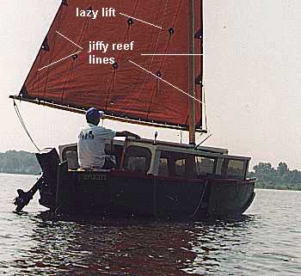
Here is how the reef lines are run:
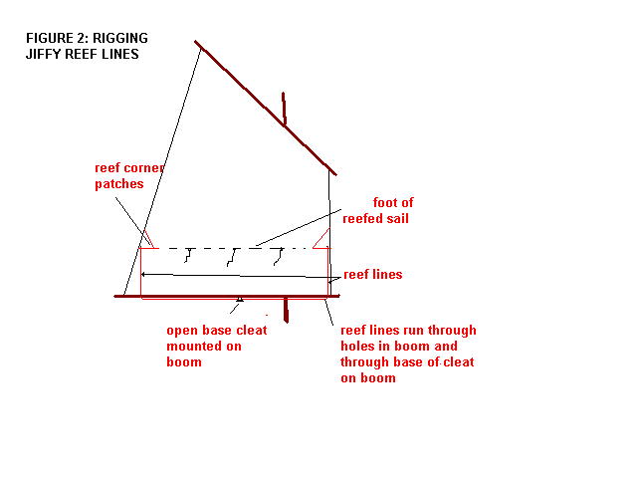
There is a reef line tied permanently to each corner patch of the new reef foot. Those lines run down through faired holes drilled in the boom end, then they run to an open based cleat near the center of the boom. In practice those two reef lines can really be just one continuous line running from one reef corner, through the boom, through the base of the cleat, throught the other hole and one to the other reef corner.
The location of the holes in the boom is fairly critical. They must be placed such that when the reef lines are pulled tight and cleated, the corners of the reefed sail are pulled down and slightly outward to stretch the foot of the sail just the right amount. Expect to experiment. Since lug sails usually taper a bit, the reef line holes tend to fall slightly inside the unreefed attachments.
The location of the cleat on the boom isn't too critical except that it should be in a place handy when reefing. Better towards the front of the boom than aft.
Here's how you reef the sail in action:
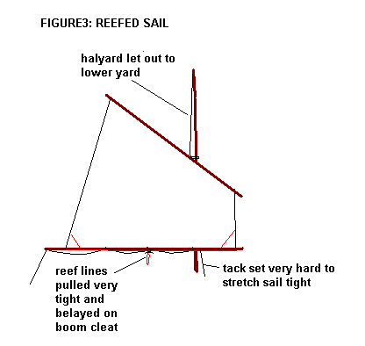
First you loosen the halyard to lower the sail. If you have a lazy lift it will gather there clear of the deck. If not, gather the lowered sail in the boat.
Next grab one of the jiffy reef lines and pull until the new reef corner is hard against the boom and cleat the line to keep it there. Then grab the other jiffy reef line and pull until that reef corner is hard against the boom and cleat that line.
Tie in the reef patches in the middle of the sail.
Hoist the sail with lots of tension in the halyard. You may want to reset the tack to put lots of tension in the luff of the sail but with this method the tack and sheet are not changed.
That's it!
Taking the reef out is even easier. Just untie the reef patches, uncleat the jiffy reef lines, and hoist back to full sail. Always make sure you have lots of tension in the luff by resetting the tack line.

